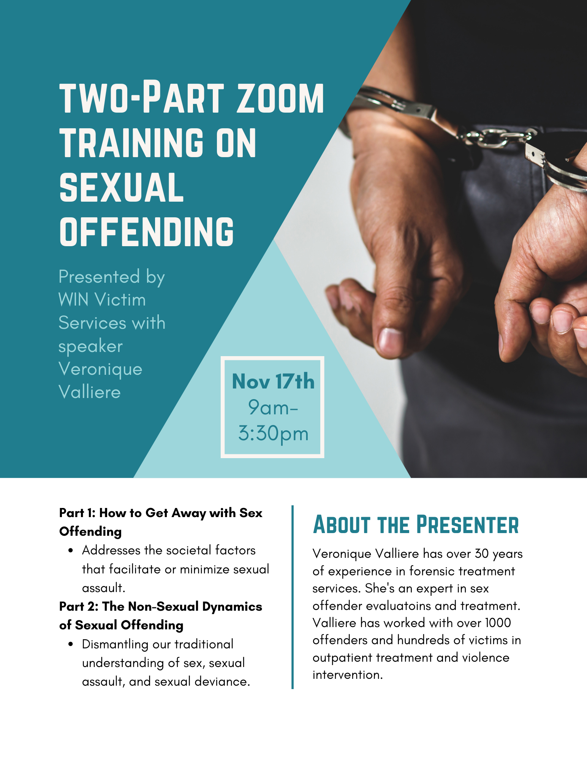
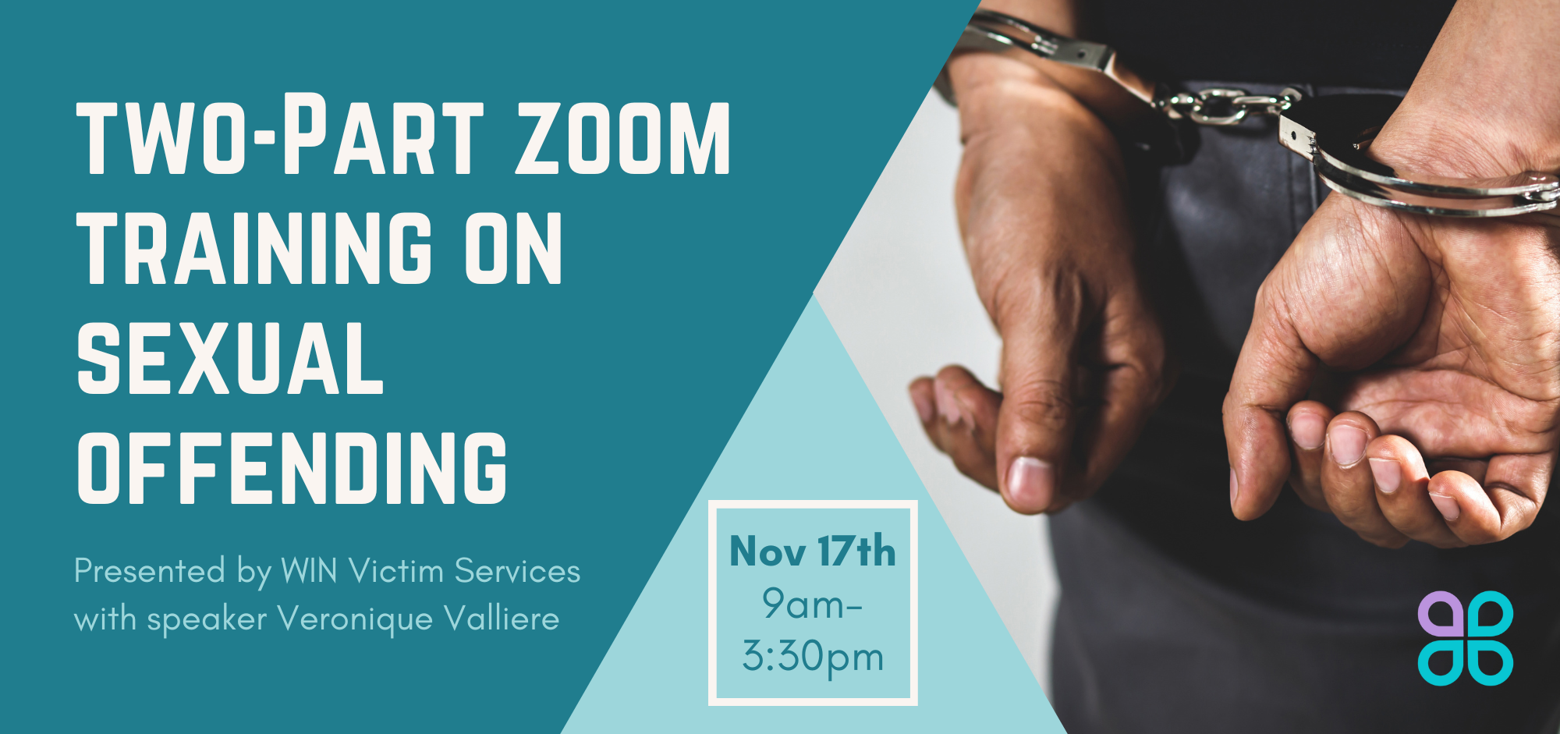
Registration is due by November 13th. To register, please complete the information below then send to Eric Williams via email (EricW@winservices.org) or fax (717-264-3168).

Name: Stephanie Lehman
Company/Agency: WIN Victim Services
Position: Community Relations Manager
Address: 1280 Progress Road, Chambersburg 17202
Phone: 717-251-3783
Email: stephaniel@winservices.org

Zoom link will be sent to all confirmed registrants on or before Wednesday, November 15th.

This project was support by grant No. ___________________ awarded by Pennsylvania Commission on Crime and Delinquency. The opinions, findings, conclusions, and recommendations expressed in this training are those of the speaker and do not necessarily reflect the views of this state or the Department of Justice, Office of Violence Against Women.

